**Prototyping Assignment #1 - Automated Restaurant**

By: Josh Zhang, & Gavin Keenan

INFO 691-001

10/23/23

**Product Description**

This document presents a speculative design and user interface (UI) and user experience (UX) considerations of an Automated Restaurant system or also referred to as ‘automated experience’. The initial system requirements for the automated experience intends for servers to physically deliver food from the kitchen and for the cooks to prepare it. The differentiation from traditional restaurant experiences however, is that restaurant patrons will be able to view available seats themselves, be guided to a seat via a ‘virtual host’, and order at any point throughout this experience. Guests will have the ability to consult with the virtual host at any point through a mobile tablet which is provided to guests at the time of check-in. Guests will be able to consult with the host at any point with any problems, questions, or feedback they might have, and including payment processes when the experience nears its end. Near the end of the guest experience, guests will be asked to place tablets back into a tray on the rear of the jukebox before exiting the restaurant.

**Storyboards**

**Guest Experience**

[Frames #1-6]:

1. Interior/Exterior of Restaurant. An arched, open-air doorway frames a Jukebox welcoming guests to enter the Restaurant. The restaurant name lies on the exterior of the building structure.
2. The guest enters the doorway and begins to interact with the Jukebox.
3. The Jukebox displays the name of the restaurant, tonight's specials, and wait time displayed on a digital LCD screen on the headboard of the device.
4. The ‘Welcome Screen’ appears on the bottom interface, desktop, touchscreen allows navigation for the guest. Selection of [Party Size, Area of Restaurant Desired, and Reservation, Payment Method & Map of Open Seats] Guests can navigate this menu to select appropriate seating for their party.
5. Guests completes (Frame #4) ‘Welcome Screen’ Experience, and the Jukebox’s mechanical mechanism opens a compartment which dispenses a mobile tablet. The Jukebox’s ‘Welcome Screen’ notifies the user to pick up the tablet.
6. User grabs the tablet and holds it in their hand.

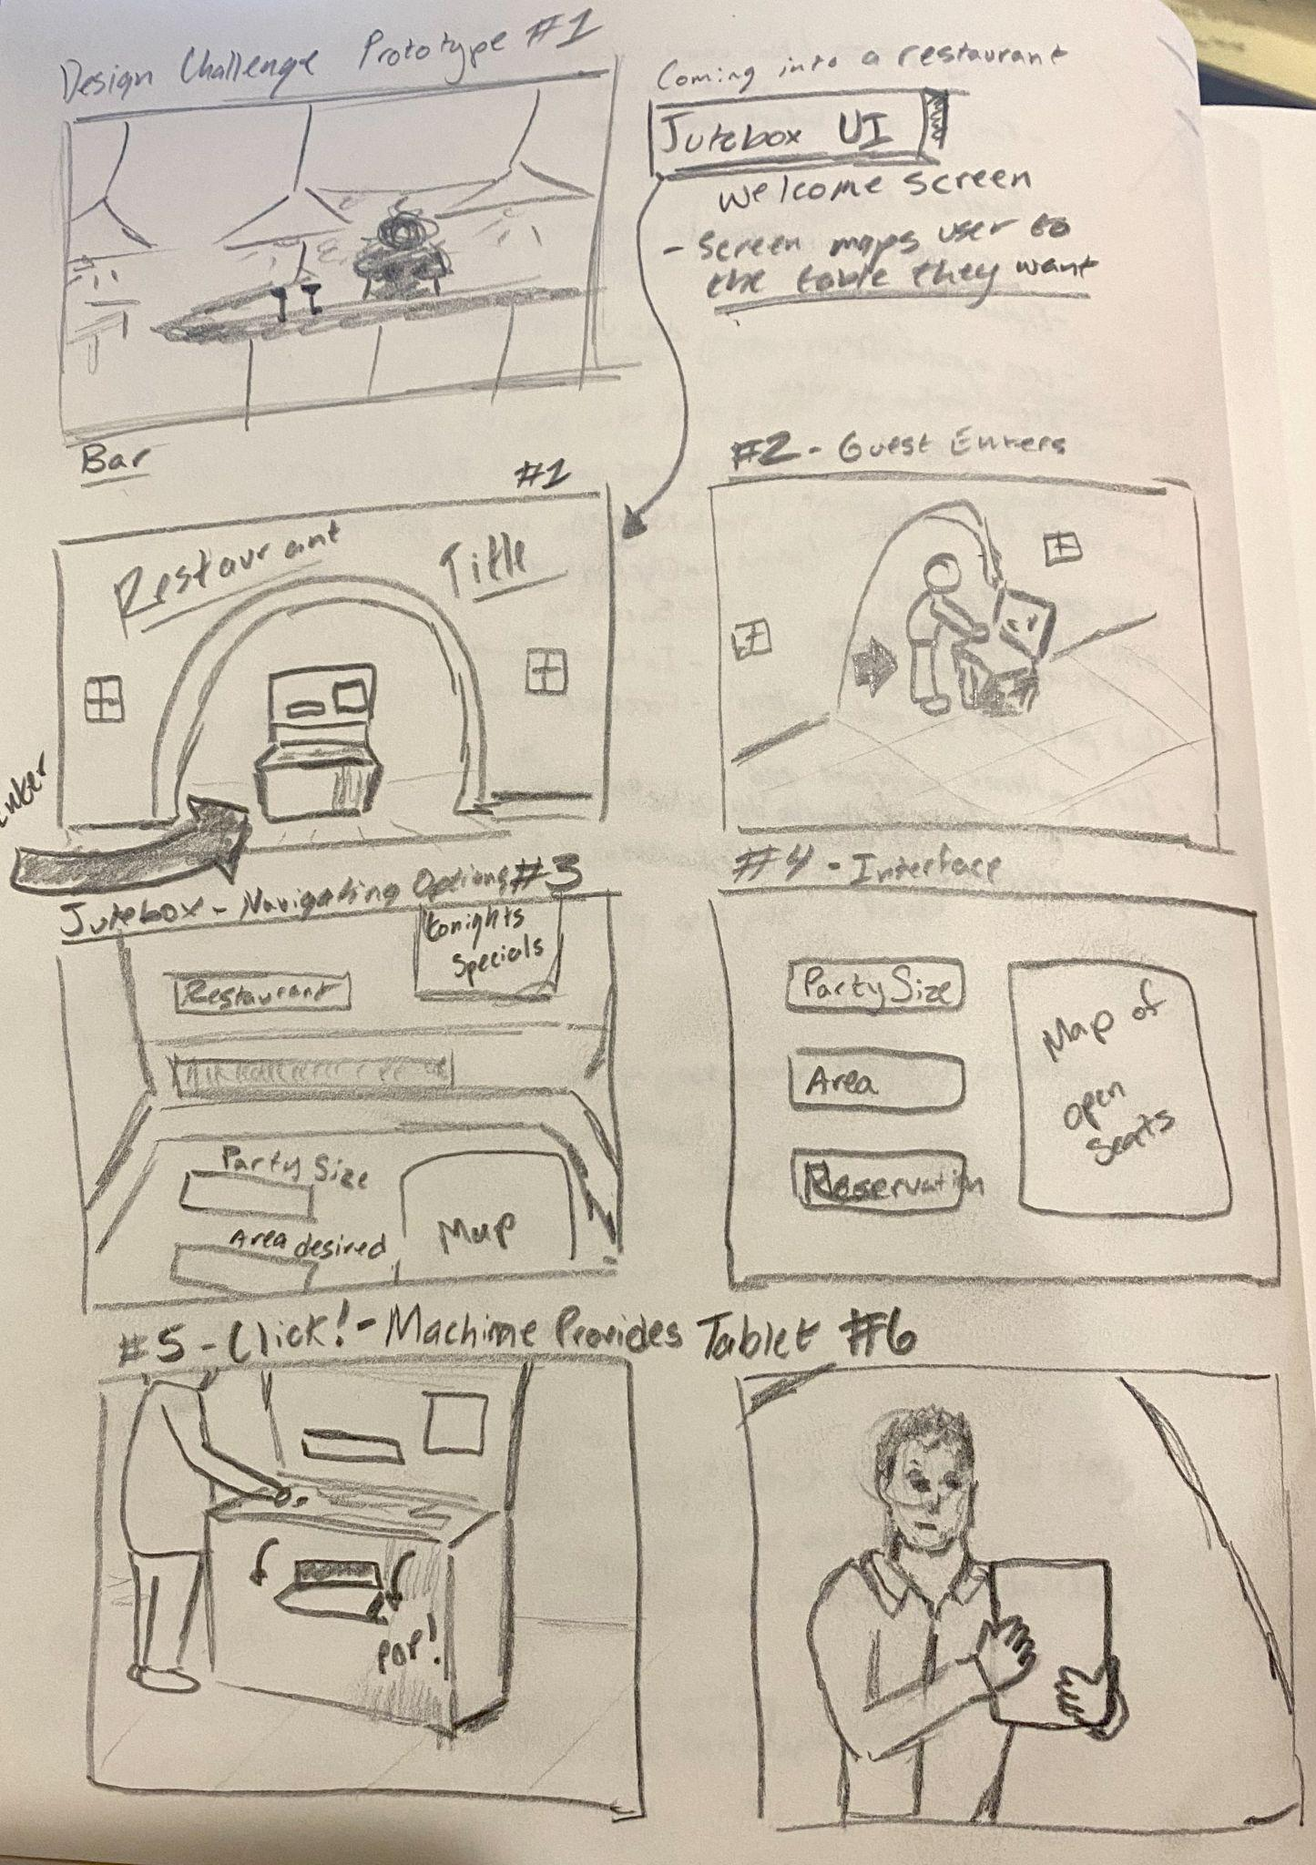

Fig 1. [Frames #1-6]

**Guest Experience**

[Frames 7-12]:

1. Guests are navigated to the table.
2. Guests sit and begin to review the menu via the tablet.
3. Guests view Welcome display 1- Specials populate the menu
4. Menu Display - Guests submit their order
5. Confirmation message of the order being submitted.

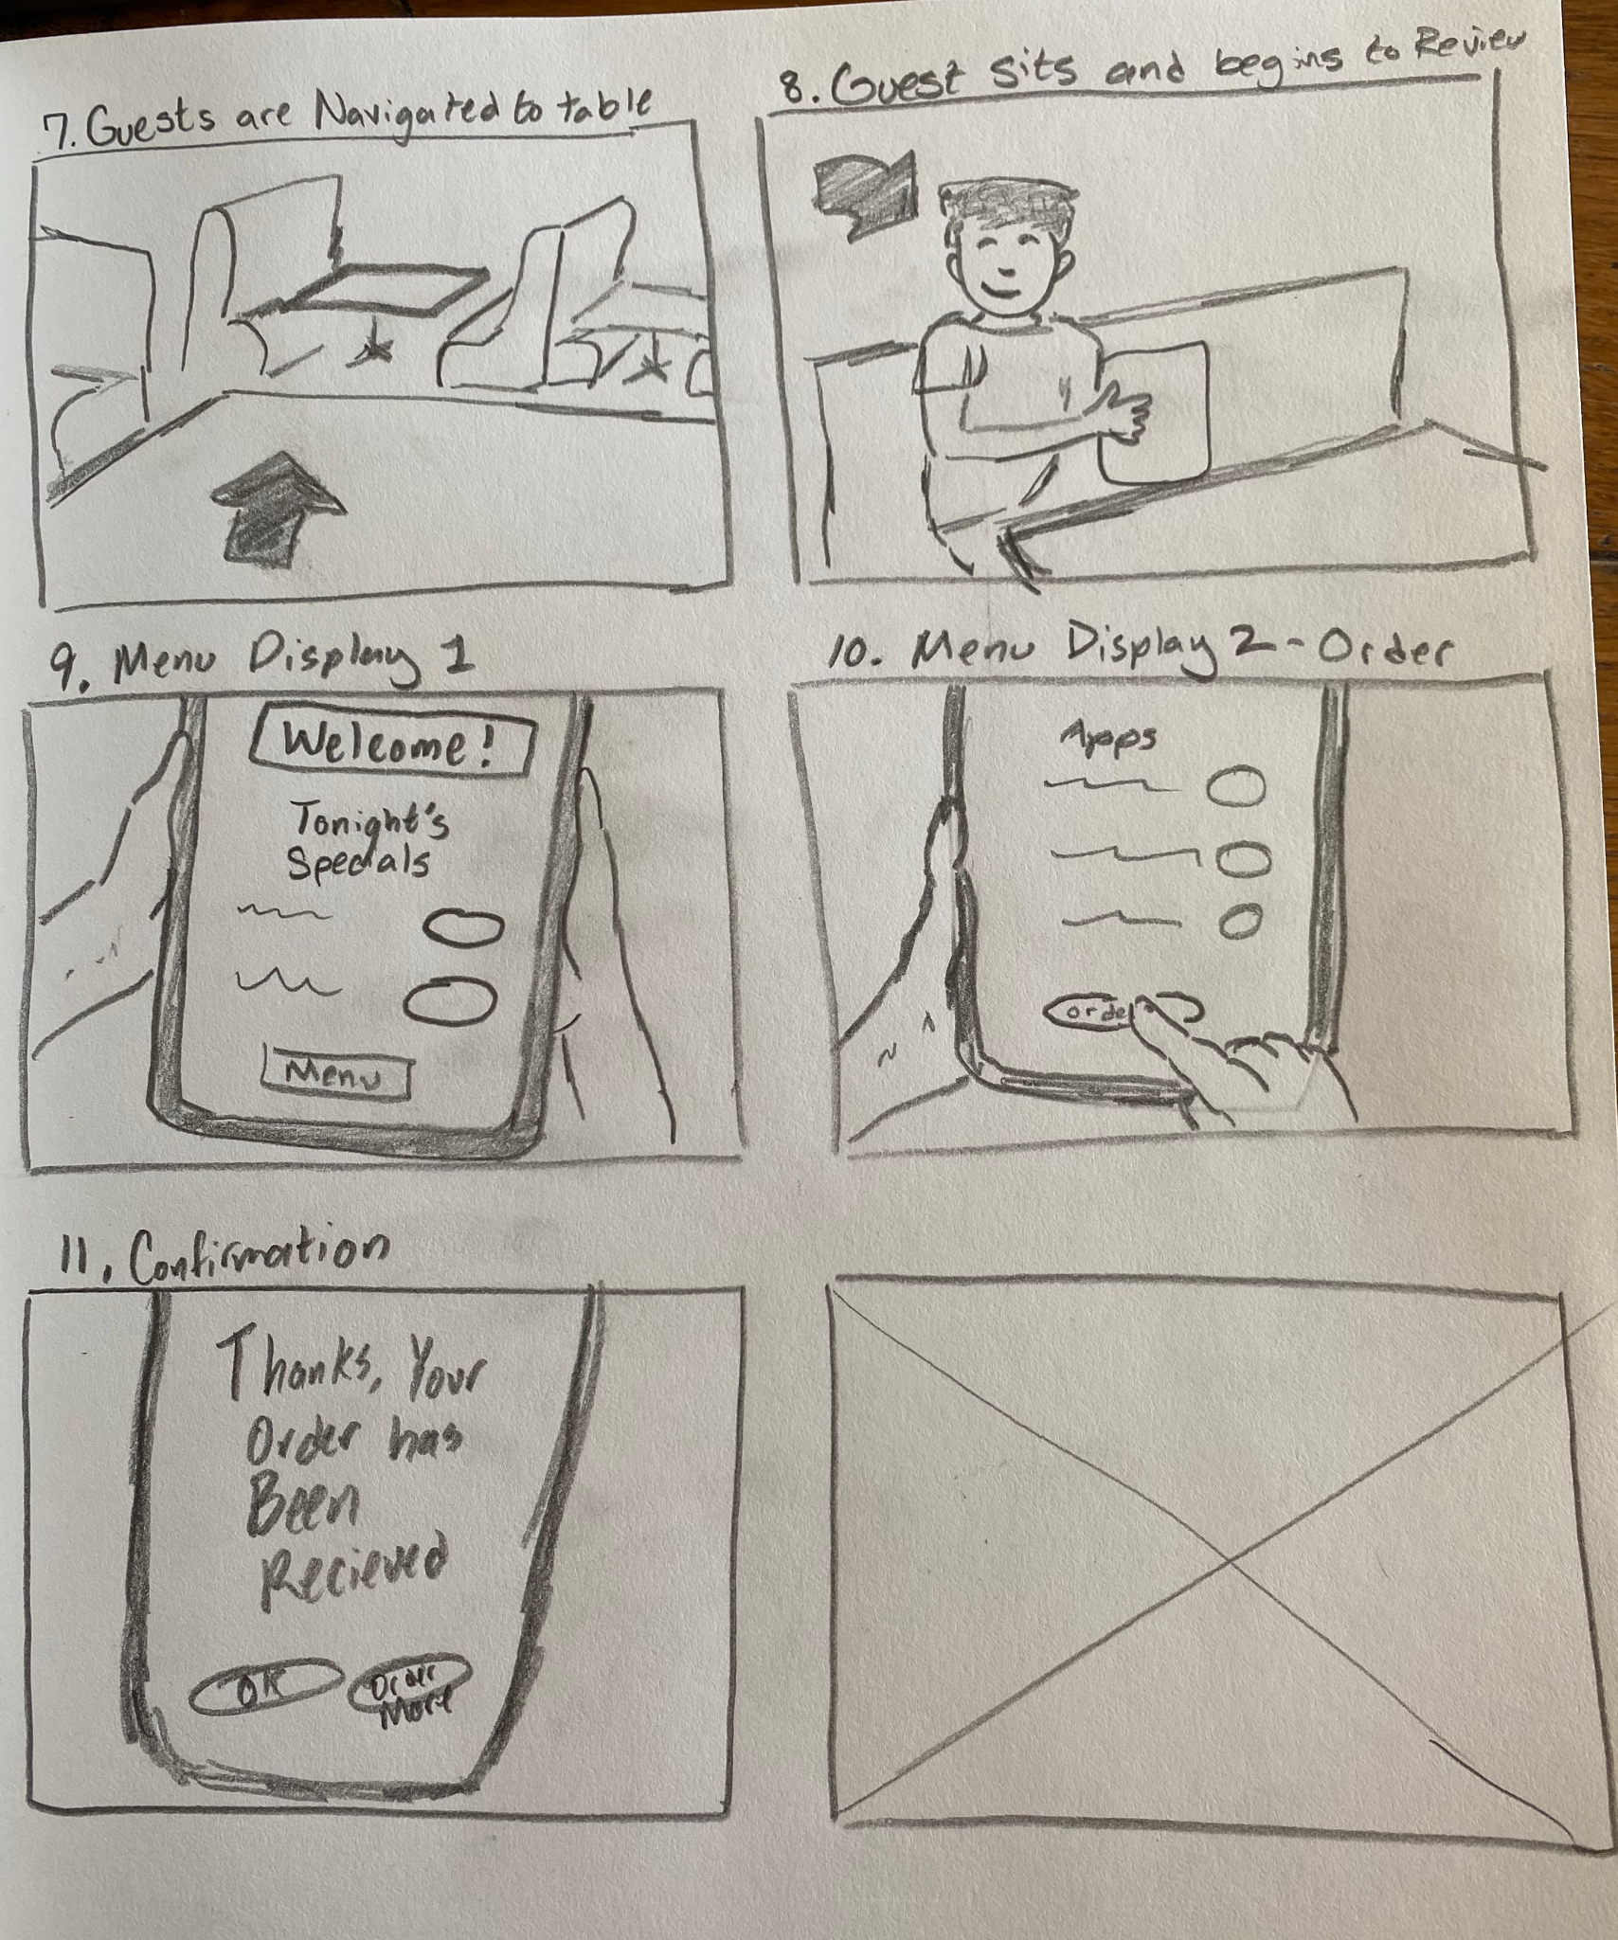

Fig 2. [Frames 7-11]

**Restaurant Staff Experience**

[Frames 13-17]

Fig. 3 [Frames 13-17]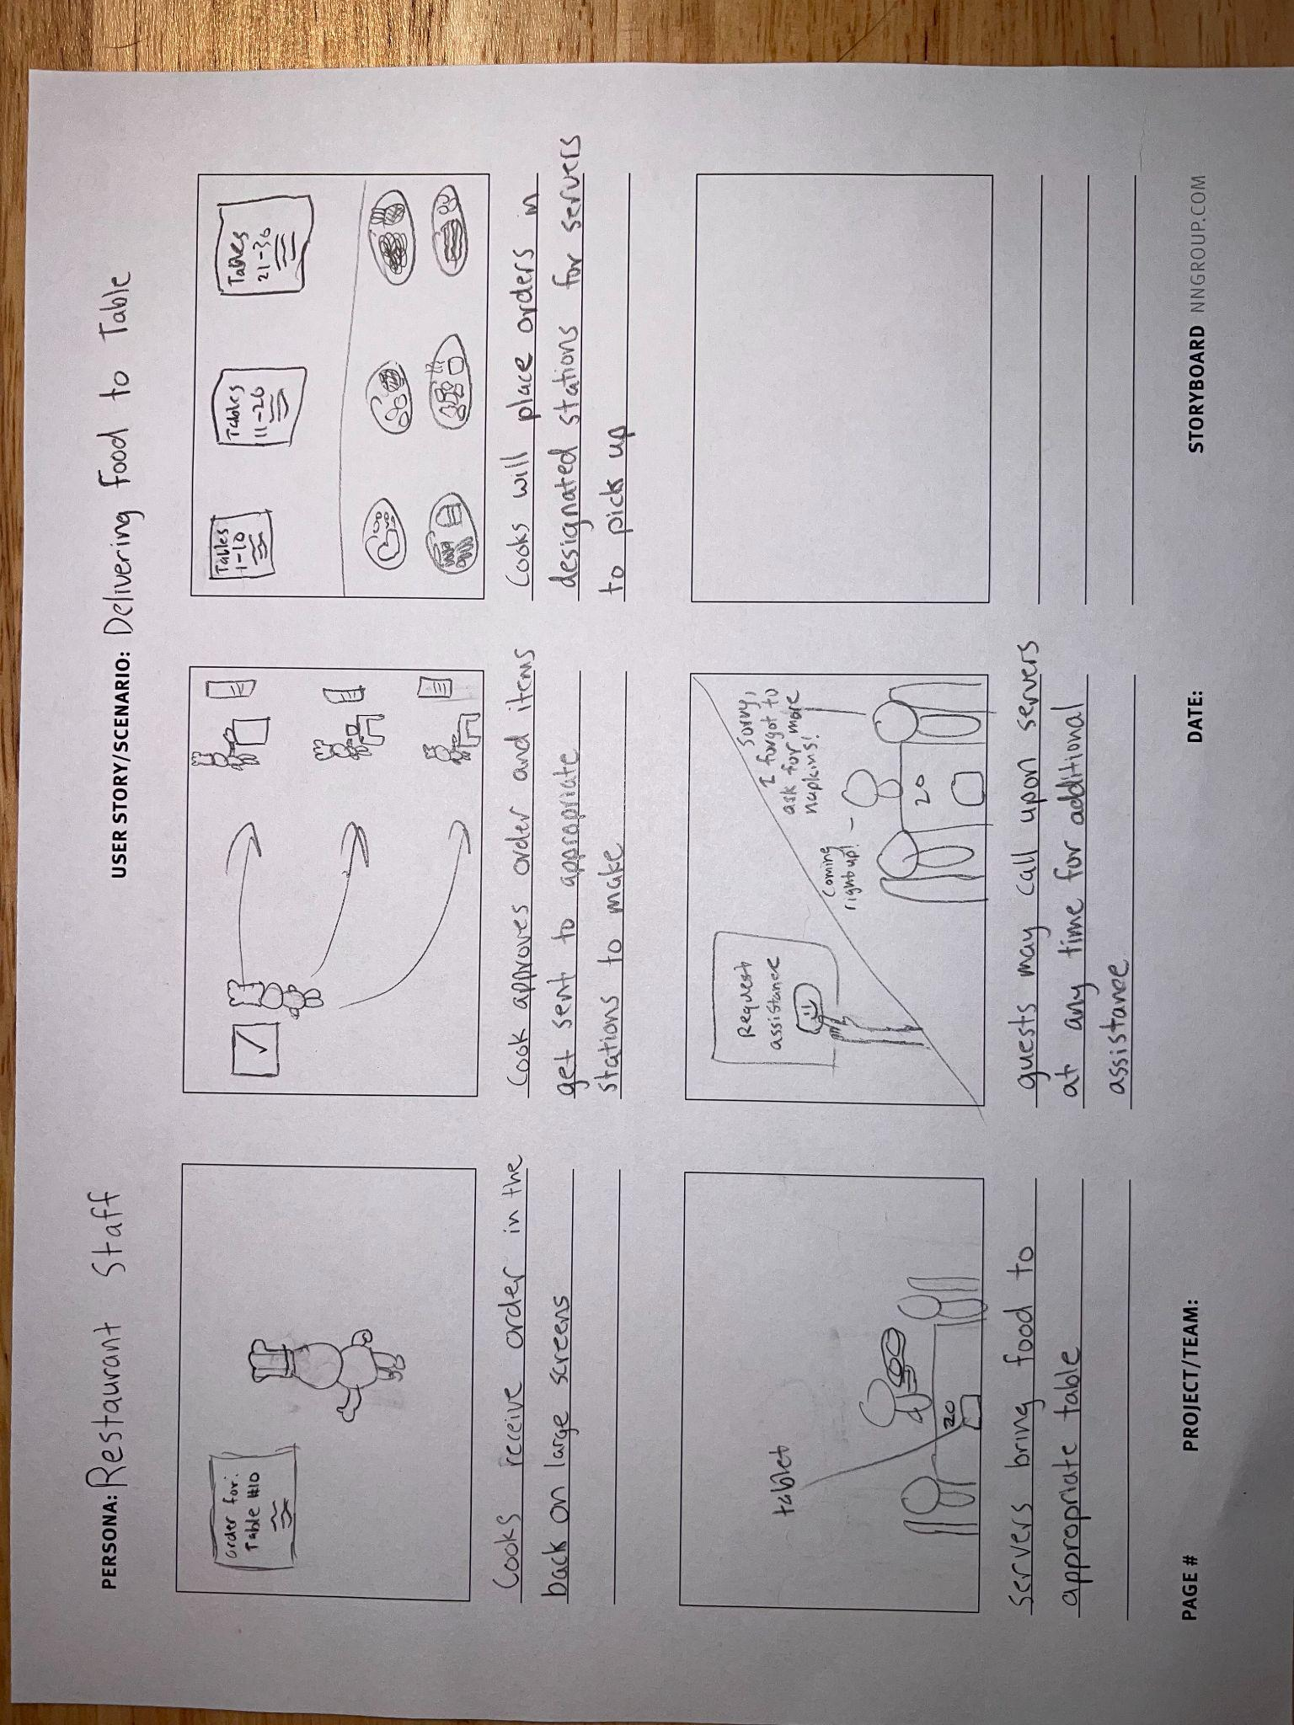

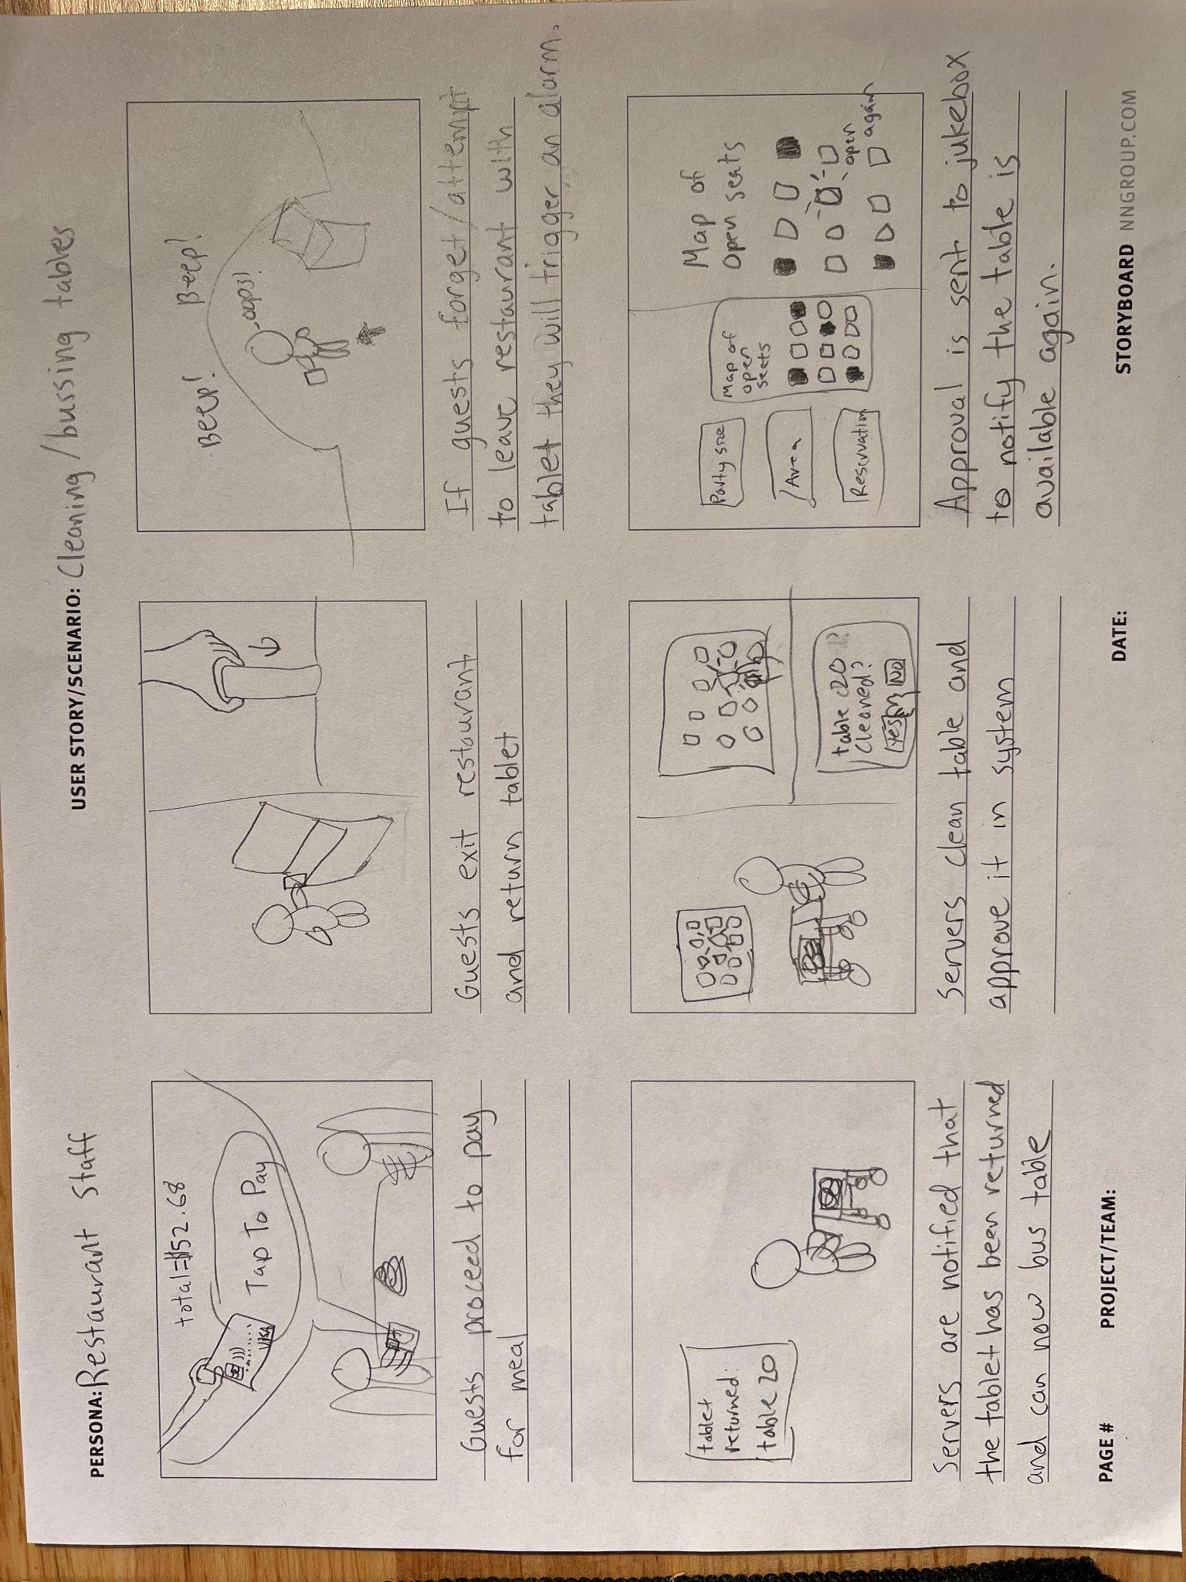

Fig. 4 [Frames 17-22]

**Story of the Storyboard**

Within these prototypes we wanted to incorporate a retro-technology into this futuristic experience, so we began with sketches of a guest first coming in contact with a jukebox. From the beginning, we wanted our process to be a familiar, but different experience in guiding the customers seamlessly from the moment they entered the restaurant. Many of the processes that were traditionally done by humans, such as guiding the user to the table and ordering, are now conducted through electronic communication on a mobile tablet. Furthermore, we envisioned that the restaurant staff experience could be designed, so that staff can receive and send out customer orders optimally. The use of the tablet on the front and backend, allows for customer assistance at any time if guests come across user errors or problems.

Through interaction with the jukebox ‘host,’ guests are able to choose preferences for restaurant seating and finding seats. After selecting and confirming seats, they are provided a mobile tablet device, which allows them to order at any point throughout the experience. The next set of storyboards show how guests navigate to their table, and view and order from the menu.

We came across issues such as theft of the tablet or servers being unsure when the customers leave the table so that they may come clean it. In order to resolve these issues we decided that there needs to be checks in place to ensure problem areas may be resolved or negated from the process entirely. We first proposed a seat sensor so that servers can see if customers are no longer sitting at the table. We also suggested an initial payment to the restaurant that ensures customers pay for their order before receiving their tablet. These problem-solving methods all come from our discussion prior to creating our storyboards.

**Feedback and Future Designs**

Based on our user feedback, there were some modifications we may need to think about for future designs. One user commented that “Not all customers may follow these steps since it's a new form of ordering”. They mentioned one flaw; if a customer does not bring the tablet back to the front of the restaurant for return. This adds a step to the employee side since they now have to incorporate placing the tablet back to the front of the restaurant if the customer forgets. One potential solution they offered, is to just have the tablets mounted at the table so that customers don’t have to think about taking a tablet around with them, but that interrupts our process of having the tablet guide users to their tables. Another user who had given feedback, enjoyed the concept of a digital host, “It feels like a good touch of nostalgia.” However, they were also skeptical of the ability for the tablet to be truly necessary, “A lot of people are already ordering on their phones with QR codes, what does the tablet help them do that they cannot already accomplish?” This perspective can be implemented further in the design cycle of this product, as the wireframes we created only contained a few mentions of the tablet integration. A potential future method could direct people to their seats through indicating a table number of the jukebox and integration of a web based interface to continue the guest experience.

**Wireframes:**

Headboard LCD Screen:

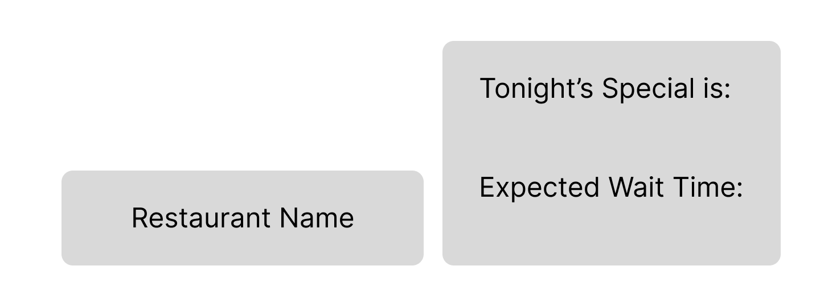

Jukebox Interface - Main Menu - Welcome Screen:

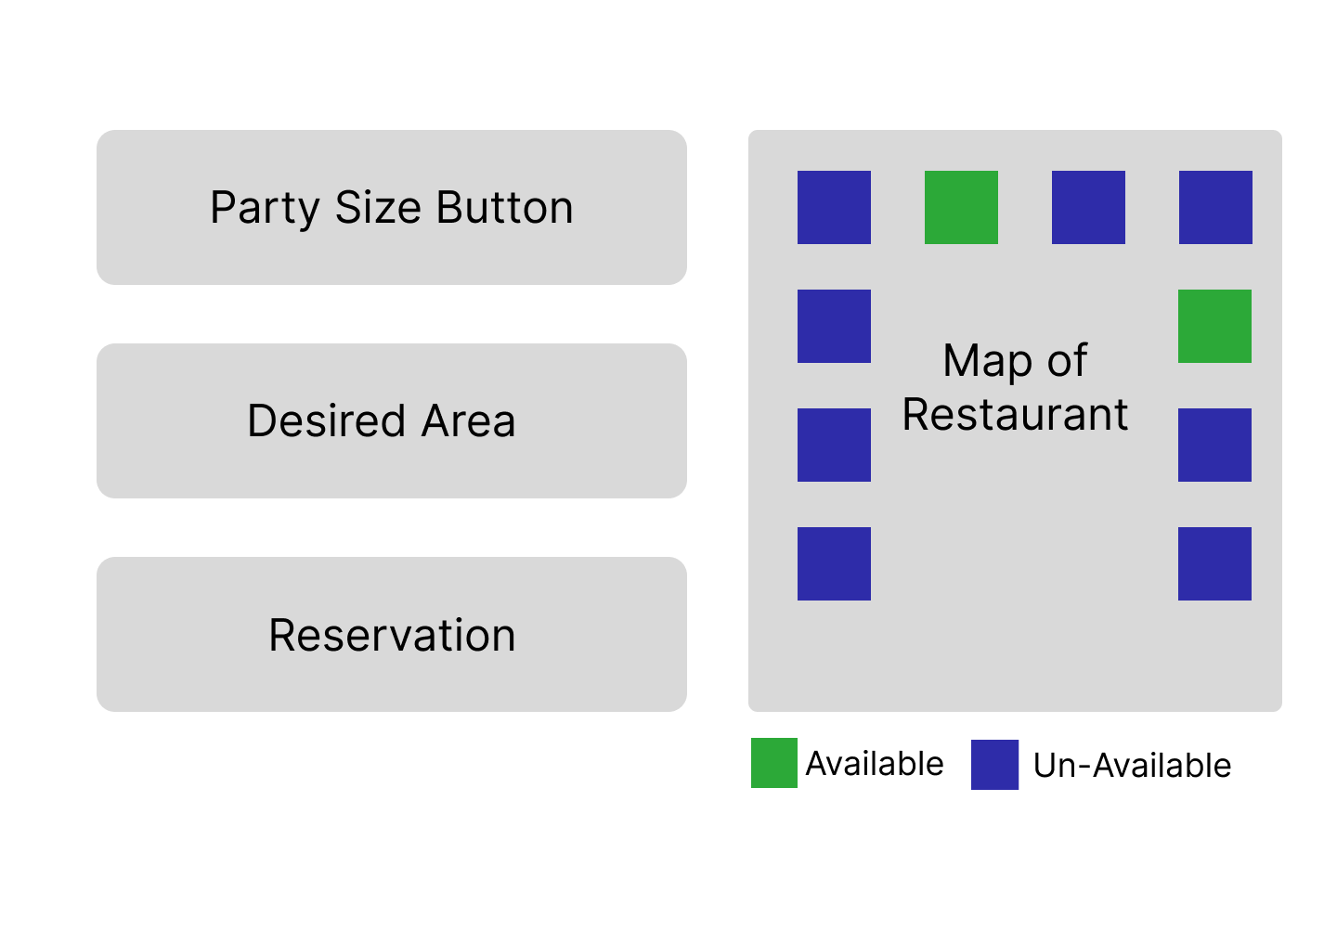

Jukebox Interface - Table Size Button Selected -Select Party Size: 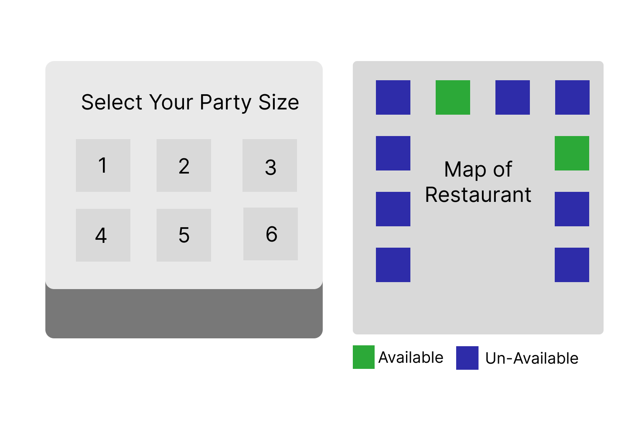

Jukebox Interface - Main Menu - Table Size Selected:

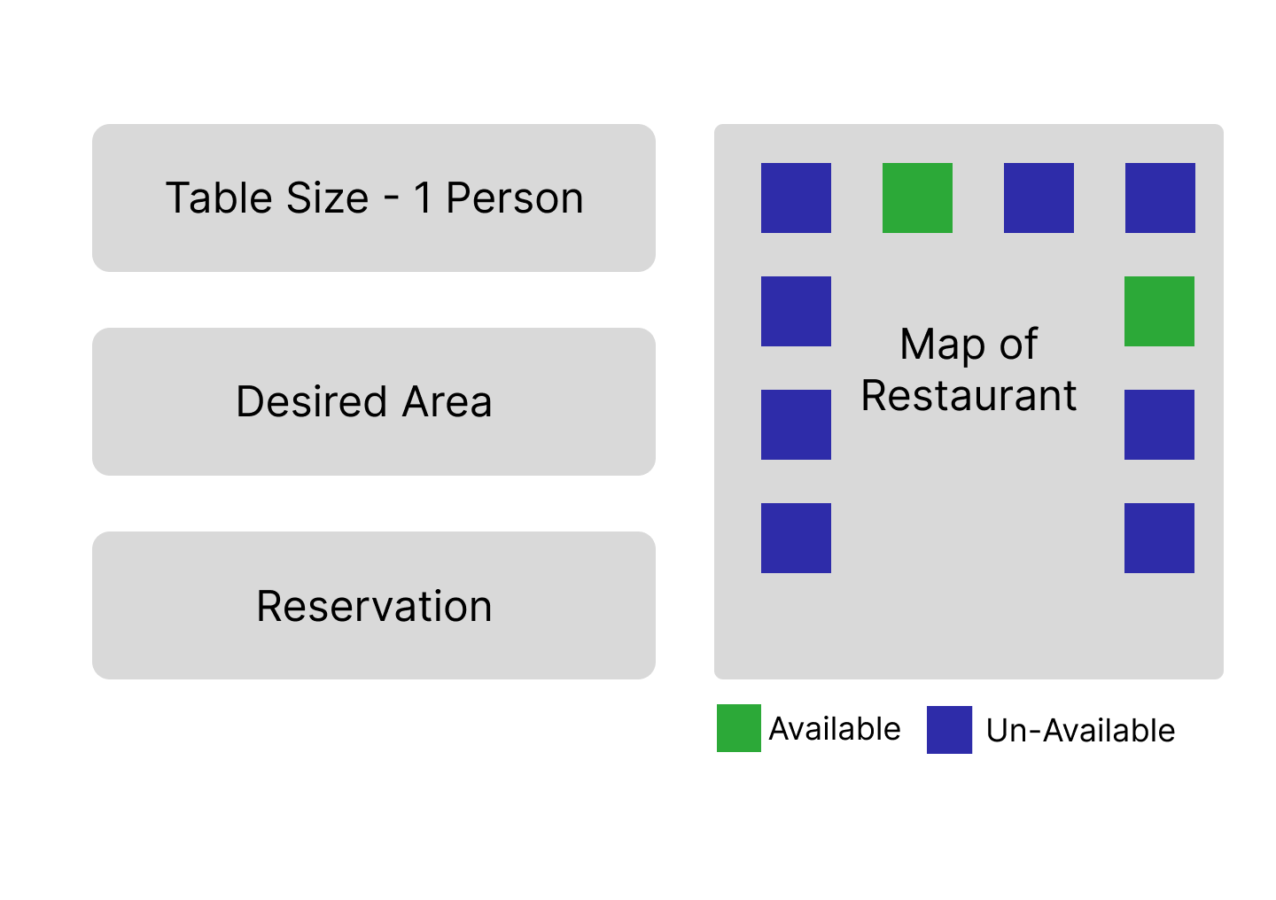

Jukebox Interface - Table Selected - Asking Guest if they would like to ‘Confirm Table’:

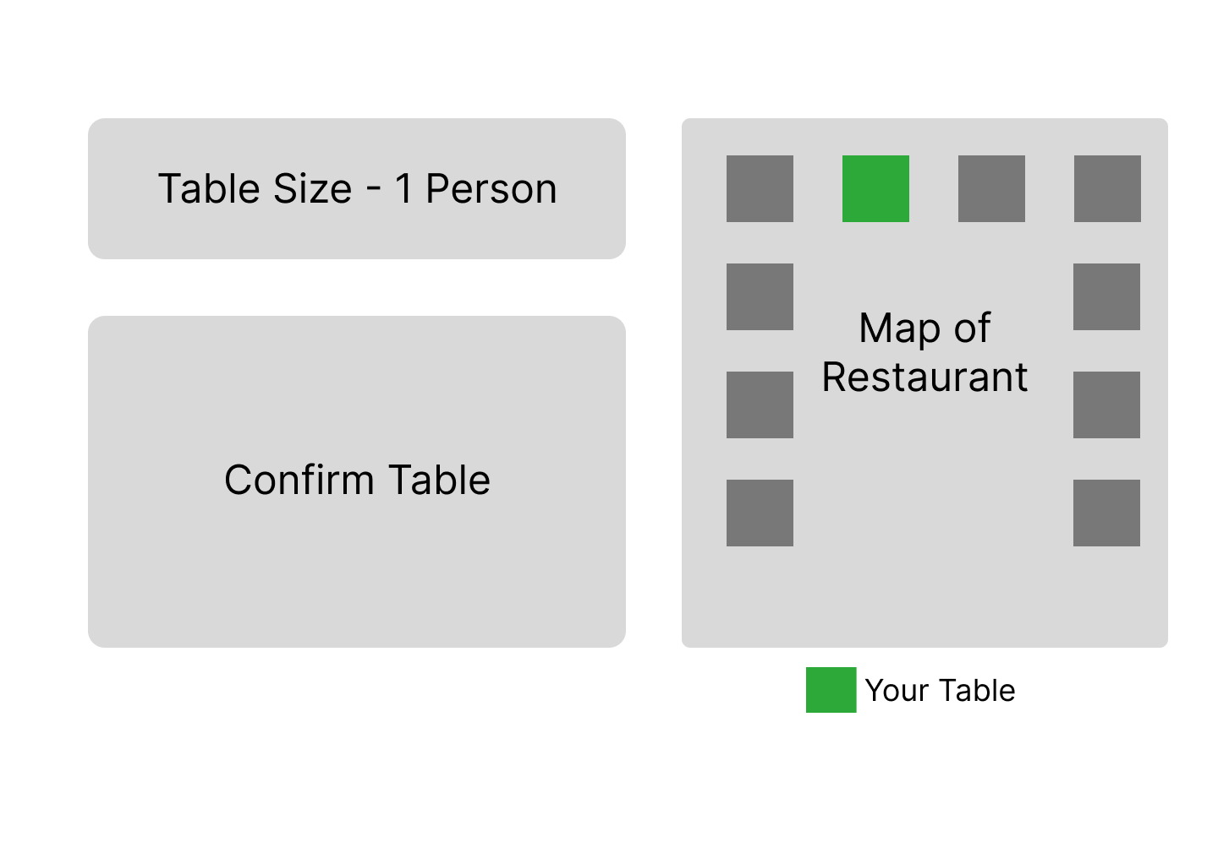

Jukebox Interface - Table Confirmed - Pick up Tablet Below:

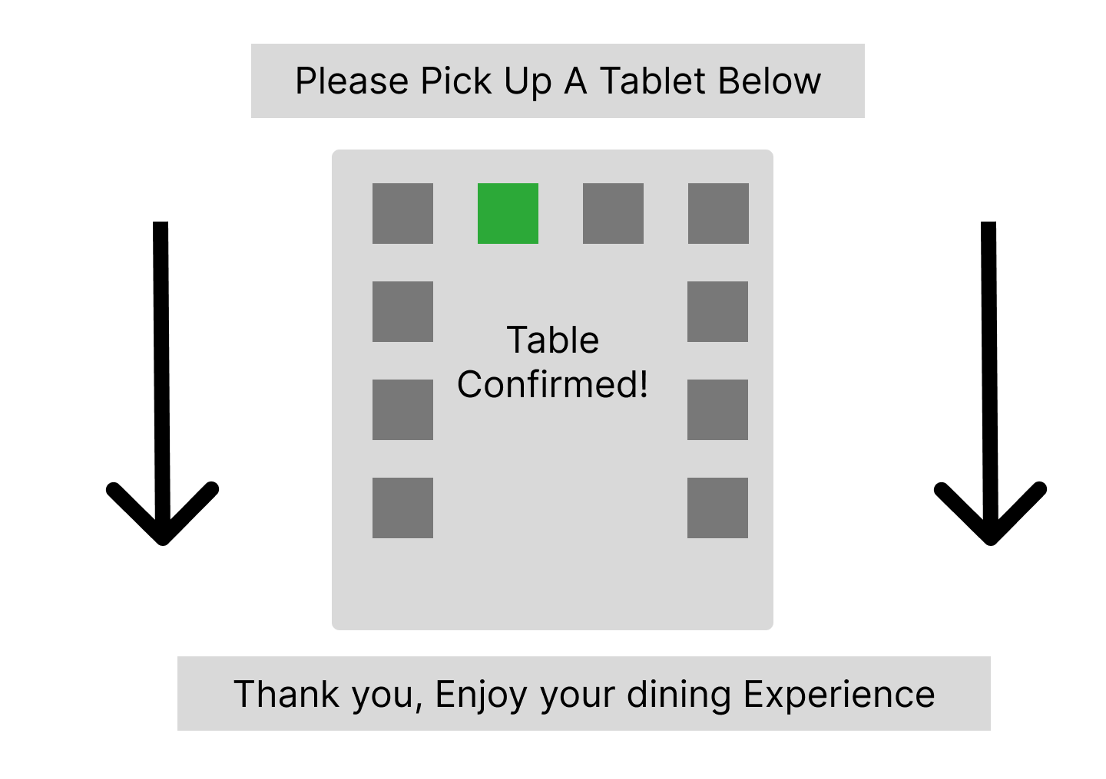

Customer Ordering - Menu Display 1 - Customer view of the first page of the menu

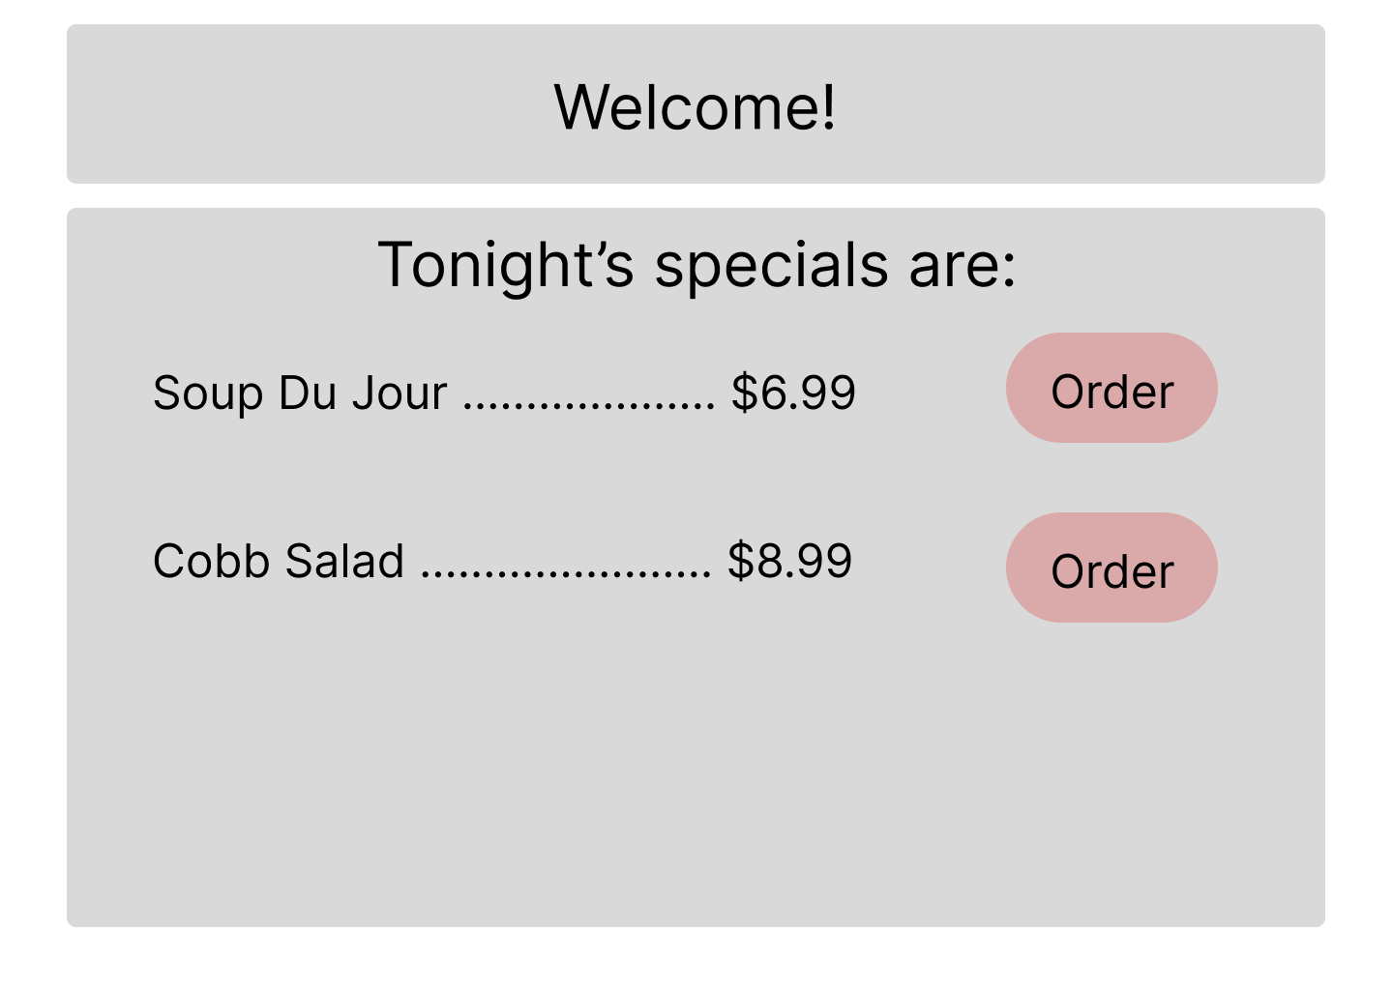

Customer Ordering - Menu Display 2 - second page of customer menu, with “place order” button at the bottom.

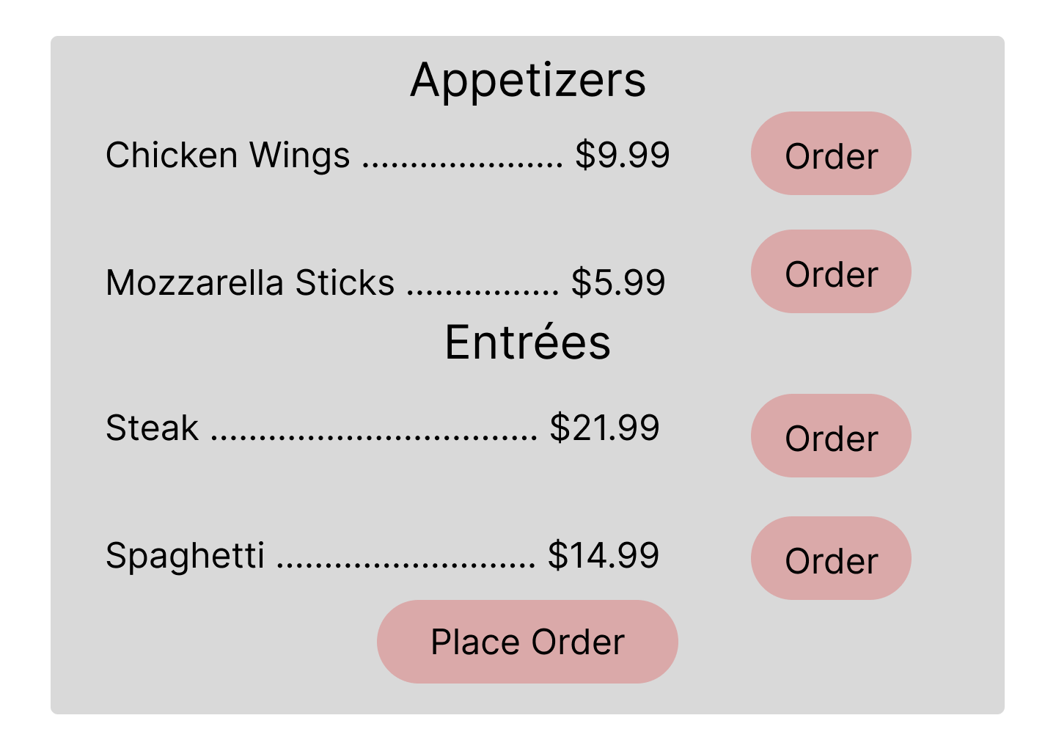

Customer Ordering - Order selection 1 - One display of a customer picking an item on the menu.

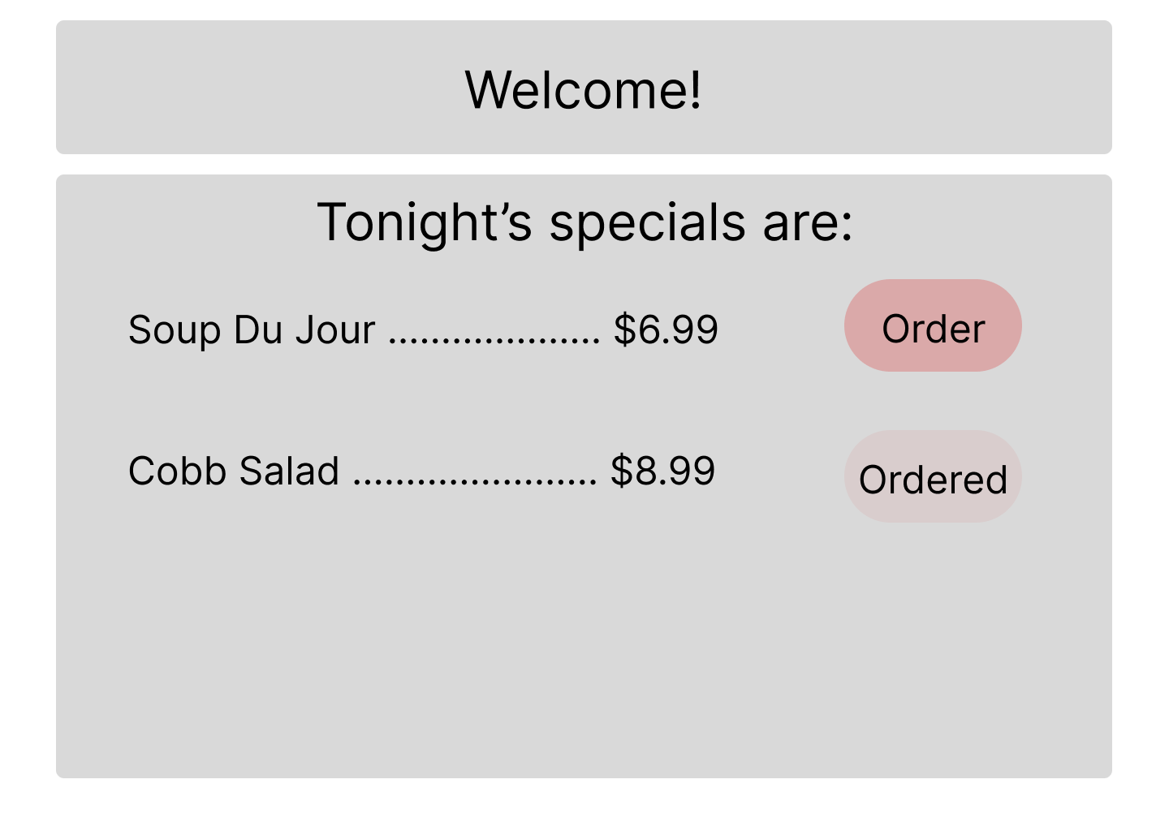

Customer Ordering - Order selection 2 - Second display of customer picking an item

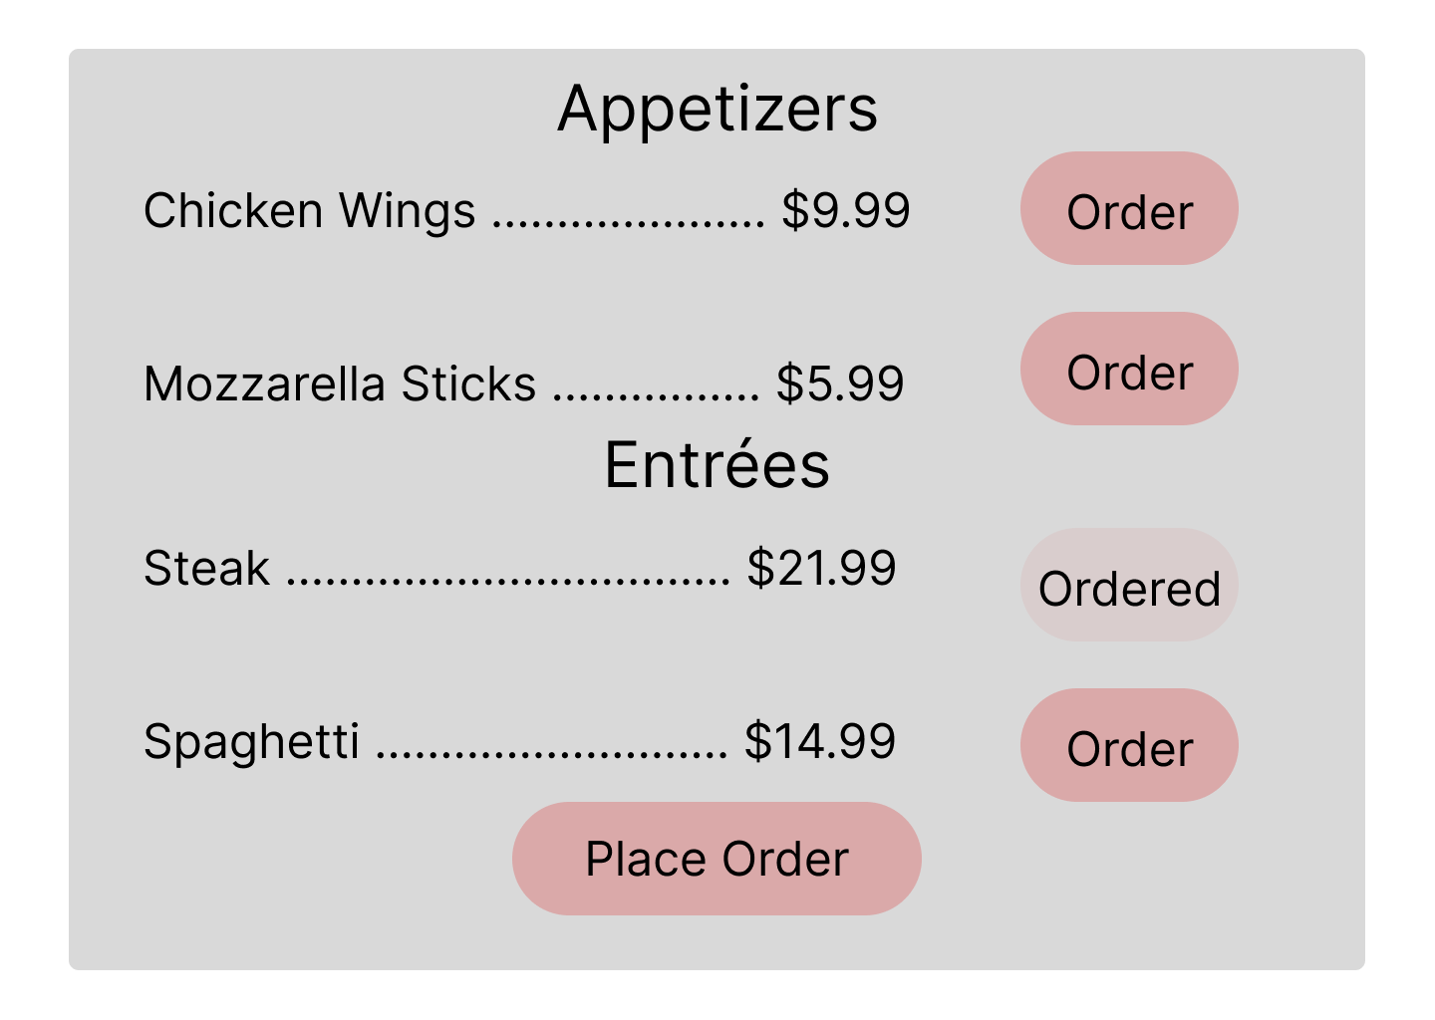

Customer Ordering - Order Confirmation - This appears after the customer has pressed the “Place Order” button at the bottom of the menu. “Order More” allows a customer to go back to add/revise choices if needed.

